A

Project Report On

**……………………STUDENT ATTENDANCE SYSTEM ……………..**

Under the Course “Java programing” (CS3153)

Submitted by

Third Year B. Tech. (Computer Engineering)

|  |  |  |
| --- | --- | --- |
| Sr. No. | Student Name | Enroll. No. |
| 1. | Pranali Laxman | 2103091 |
| 2. | Sanika Vilas Sutar | 2103094 |
| 3. | Sankalp Sambhaji Kamble | 2103108 |
| 4. | Tanaya Shivaji Shinde | 2103110 |

Under the Guidance of

Prof. Mr. D.J.Datttwadkar Sir.



Computer Science and Engineering Department

K. E. Society’s

**Rajarambapu Institute of Technology, Rajaramnagar**

(An Autonomous Institute Affiliated to Shivaji University, Kolhapur)

**2023-24**

K. E. Society’s

**Rajarambapu Institute of Technology, Rajaramnagar**

(An Autonomous Institute Affiliated to Shivaji University, Kolhapur)

------------------------------------------------------------------------------------------------

**CERTIFICATE**

This is to certify that below mentioned students of T.Y B.Tech. (CSE) have successfully completed the project entitled ***“STUDENT ATTENDANCE SYSTEM”*** under the course “Java programming” (CS3153). The content of this report, in full or in parts, have not been submitted to any other institution or university for the award of any degree.

|  |  |  |
| --- | --- | --- |
| Sr. No. | Student Name | Enroll. No. |
| 1. | Pranali Laxman | 2103091 |
| 2. | Sanika Vilas Sutar | 2103094 |
| 3. | Sankalp Sambhaji Kamble | 2103108 |
| 4. | Tanaya Shivaji Shinde | 2103110 |

Prof. Mr. D. J. Dattawadkar Prof. Dr. S. U. Mane

Project Guide HOD, CSE. Dept.

Place : R.I.T., Rajaramnagar

Date : 04.12.2023

**DECLARATION**

We, the undersigned, the students of S. Y. B. Tech. (CSE) hereby declare that the project the project entitled ***“STUDENT ATTENDANCE SYSTEM”*** under the course “Java Programming” (CS3153) is a genuine work conducted by us through practical on–site observations, and the data collected by us is true to the extent of our awareness.

|  |  |  |
| --- | --- | --- |
| Sr. No. | Student Name | Enroll. No. |
| 1. | Pranali Laxman | 2103091 |
| 2. | Sanika Vilas Sutar | 2103094 |
| 3. | Sankalp Sambhaji Kamble | 2103108 |
| 4. | Tanaya Shivaji Shinde | 2103110 |

Place : R.I.T., Rajaramnagar

Date : 04.12.2023

**ACKNOWLEDGEMENT**

The success and final outcome of this project required a lot of guidance and assistance from many people and I am extremely privileged to have got this all along the completion of my project. All that I have done is only due to such supervision and assistance and I could not forget to thank them.

Respect and thank **Prof. D.J.Dattwadkar** for providing us an opportunity to do the project work in and giving us all support and guidance which made me complete the project duly. I am extremely thankful for providing such a nice support and guidance, although he had a busy schedule managing his own time.

Heartly thankful and fortunate enough to get constant encouragement and support and guidance from all teaching staff of CSE which helped us in successfully completing our project work.

**Contents**

|  |  |  |
| --- | --- | --- |
| **Chapter No.** | **Content** | **Page No.** |
| Chapter 1 | Introduction | **6** |
|  | Components used in GUI | **7** |
|  | Application used component used in real life | **8** |
|  | Snapshots | **9** |
|  | Conclusion | **10** |
|  | Refernece | **11** |

**Introduction**

Java is a programming language and a platform. Java is a high level, robust, object-oriented and secure programming language. Java was developed by Sun Microsystems (which is now the subsidiary of Oracle) in the year 1995. James Gosling is known as the father of Java. Before Java, its name was Oak. Since Oak was already a registered company, James Gosling and his team changed the name from Oak to Java.MySQL is a fast, easy-to-use RDBMS being used for many small and big businesses. MySQL is developed, marketed and supported by MySQL AB, which is a Swedish company. MySQL is becoming so popular because of many good reasons −

* + MySQL is released under an open-source license. So you have nothing to pay to use it.
  + MySQL is a very powerful program in its own right. It handles a large subset of the functionality of the most expensive and powerful database packages.
  + MySQL uses a standard form of the well-known SQL data language.

MySQL Workbench is a visual [database design](https://en.wikipedia.org/wiki/Database_design) tool that integrates [SQL](https://en.wikipedia.org/wiki/SQL) [development](https://en.wikipedia.org/wiki/Software_development), [administration,](https://en.wikipedia.org/wiki/Database_administration) [database design,](https://en.wikipedia.org/wiki/Database_design) creation and maintenance into a single [integrated development](https://en.wikipedia.org/wiki/Integrated_development_environment) [environment](https://en.wikipedia.org/wiki/Integrated_development_environment) for the [MySQL](https://en.wikipedia.org/wiki/MySQL) database system. A database is a separate application that stores a collection of data. Each database has one or more distinct APIs for creating, accessing, managing, searching and replicating the data it holds.

Nowadays, we use relational database management systems (RDBMS) to store and manage huge volumes of data. This is called relational database because all the data is stored into different tables and relations are established using primary keys or other keys known as Foreign Keys. Java Swing tutorial is a part of Java Foundation Classes (JFC) that is used to create window-based applications. It is built on the top of AWT (Abstract Windowing Toolkit) API and entirely written in java.

Unlike AWT, Java Swing provides platform-independent and lightweight components.The javax.swing package provides classes for java swing API such as JButton, JTextField, JTextArea, JRadioButton, JCheckbox, JMenu, JColorChooser etc.

**Components used in GUI**

In developing a Student Attendance database using Swing, Swing itself is the primary component or framework utilized for building the user interface (UI) of the application. Swing is a GUI (Graphical User Interface) toolkit within Java that provides a rich set of components to create a user-friendly interface for Java applications.

Within Swing, various components are employed to design the user interface of a Student Attendance database application:

1. JFrame : The main window or frame of the application where other components are added.

2. JPanel : Containers used to organize and manage other components within the frame.

3. JLabel : Display labels or descriptions for various fields or sections in the UI.

4. JTextField :Input fields for entering text or information such as patient names, medical history, etc.

5. JButton : Interactive buttons to perform actions like saving, searching, or updating patient records.

6. JTable : To display and manage tabular data, such as patient records, in a structured manner.

7. Layout Managers : Used to arrange and organize components within the frame, such as BorderLayout, GridLayout, etc.

These Swing components enable the creation of a visually appealing and functional user

interface for the hospital patient database application. Developers utilize these components to design the layout, handle user interactions, input validation, and data

presentation within the application.

However, while Swing provides a robust set of components for building the UI, it's essential to integrate it with appropriate backend technologies and database management systems (such as JDBC for database connectivity, and MySQL, Oracle, or PostgreSQL for storing patient data) to create a complete and functional hospital patient database application.

**Application Of Component Used in Real Life**

The components used in the Java program for a hospital patient record application have real-world applications in various software systems, particularly in healthcare and beyond. Here's how each component can be applied in practical scenarios:

1. Text Fields (JTextField) : These are used for entering patient names, contact information, or any textual data. In real-world applications, text fields are used for inputting various information across systems, such as entering customer details in banking apps or filling out forms in online registrations.

2. Labels (JLabel) : Labels are used to provide descriptions or titles for fields, enhancing user understanding. In healthcare, labels can represent patient details, medication names, or diagnosis titles in electronic medical records (EMR) systems.

3. Combo Boxes (JComboBox) :Dropdown lists are valuable in selecting predefined options like blood groups. In healthcare, combo boxes might be used for selecting medical conditions, drug names, or appointment types.

4. Buttons (JButton) : Buttons trigger actions, such as inserting patient records in this case. Similarly, in other applications, buttons perform actions like saving data, submitting forms, or initiating transactions in banking systems.

5. Mouse Events (MouseAdapter): These events are used to create interactive UI elements, such as changing button colors when hovered over. In real-world applications, this functionality is employed for interactive elements in websites or applications to provide visual feedback to users.

6. Text Areas (JTextArea) : Text areas allow for multiline text input, ideal for capturing extensive information like medical history or treatment descriptions. They are used in EMR systems to record detailed patient histories or clinical notes.

7. Database Interaction (JDBC, SQL) :Connecting to a database, executing SQL queries, and inserting patient data demonstrate integration with a database management system. In real-world healthcare systems, database interactions are crucial for storing and managing patient records securely.

In practical healthcare systems, these components contribute to user-friendly interfaces, efficient data input, and effective management of patient information, ensuring accuracy and accessibility for healthcare professionals managing patient records.

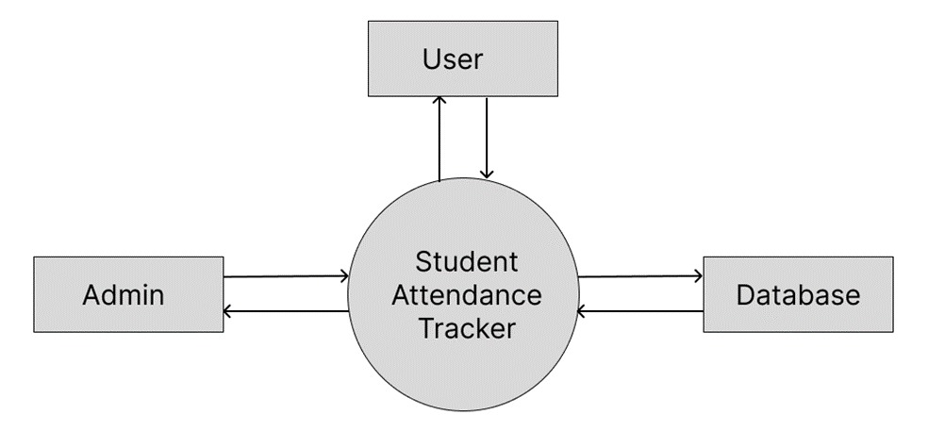

Above diagram represents the DFD of the student attendance tracker. In this, various tasks can be performed , and the changes are reflected in the database at the backend. three entities are considered, namely- ADMIN, USER, database, in which intermediary is student attendance tracker. And the flow is directed from ADMIN to student attendance tracker and then to the database and also from Database to SAT and to ADMIN. And user to database and database to user.

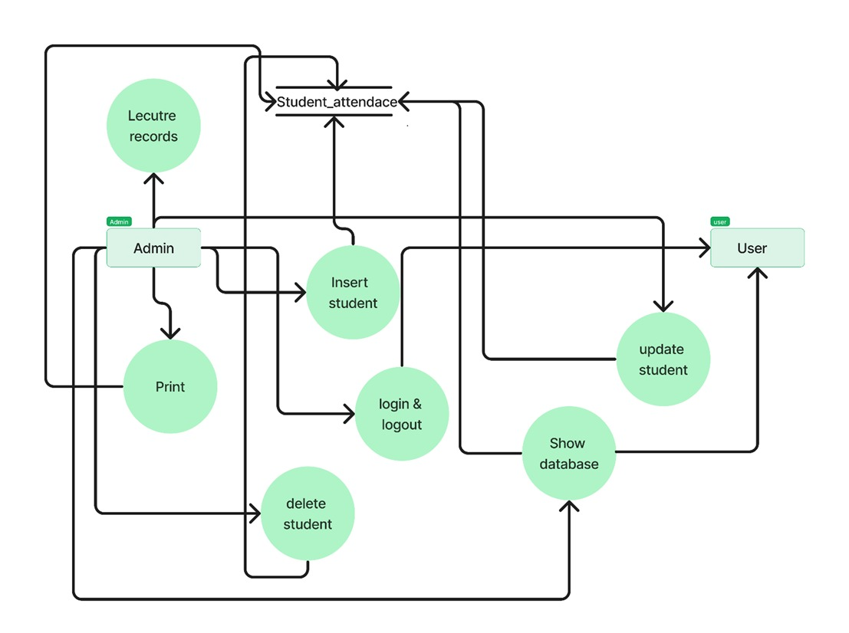

**Snapshots**

Description of components of code: -

The code designed for the student attendance tracker. Basically, it comprises the six functions. Among those, “Student Attendance Tracker” is the main function. Other functions are designed to perform/accomplish the different purpose of the system. The system is able to Login by the user or the admin who is using the student attendance system. And then it can perform the operations like insert student data and attendance, delete the existing student, and update the required information of the student. Also, we can print the attendance sheet of the students.

1) Login of user or admin.

2) Add student data.

3) Update Attendance & Show data.

4) Delete existing student.

**1.Login Page**

This function identifies the admin by authentication process. This function matches the set username of the user and admin with the password & grant the permission for accessing the student attendance tracker system. If the username and password specification does not match it simply give pop up msg of invalid username or password.

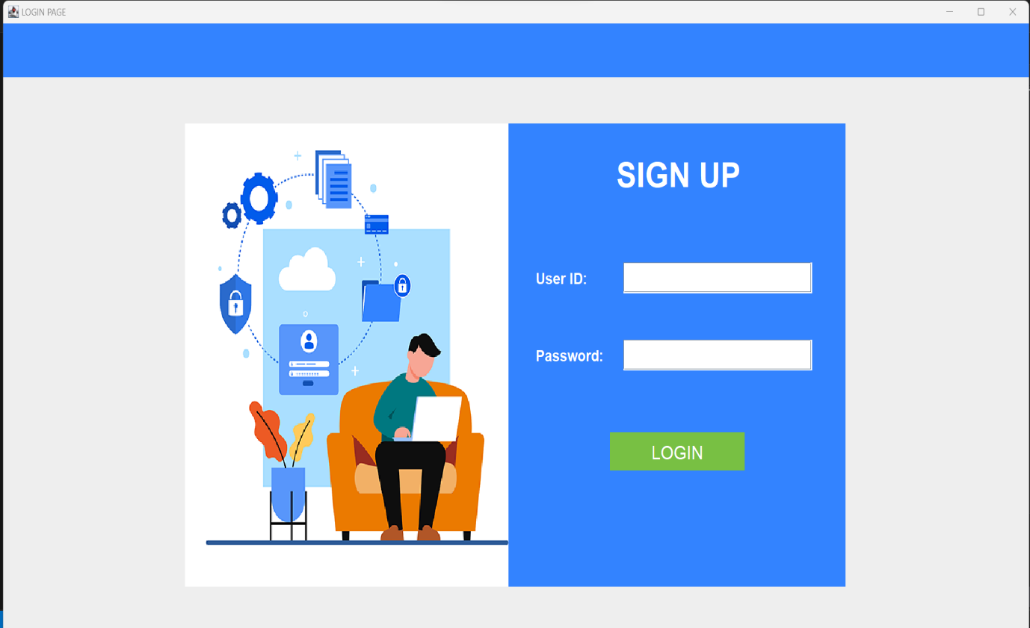

**2.Hero Page**

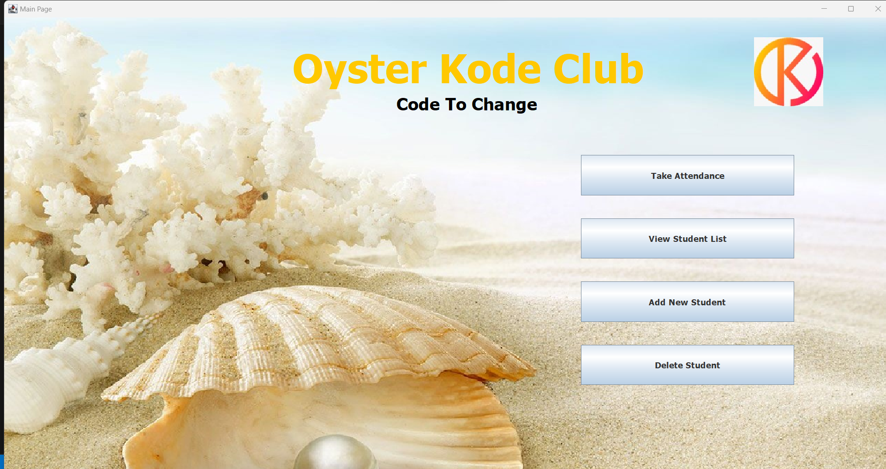

**3.Take Attendance**

**4.View Attendance**

This module is used to update the existing attendance of any student where it is by mistakenly marked absent of present by the admin. It can correct the manipulated values of the student attendance data. Also, it shows the data base of the student who have conducted and not conducted the lecture

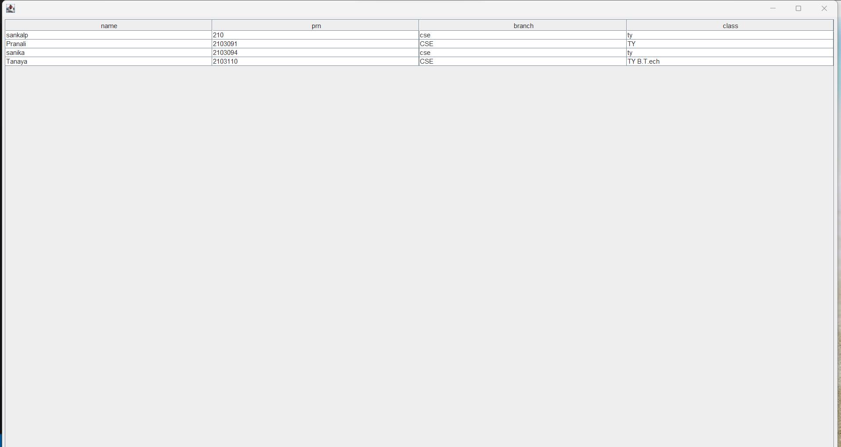

**5.Add New Student**

This function enables the feature for the admin to insert the student information data and the number of lectures attended by the student out of the total lecture conducted. In the given database it also calculates the percentage of the student attendance while inserting the data.

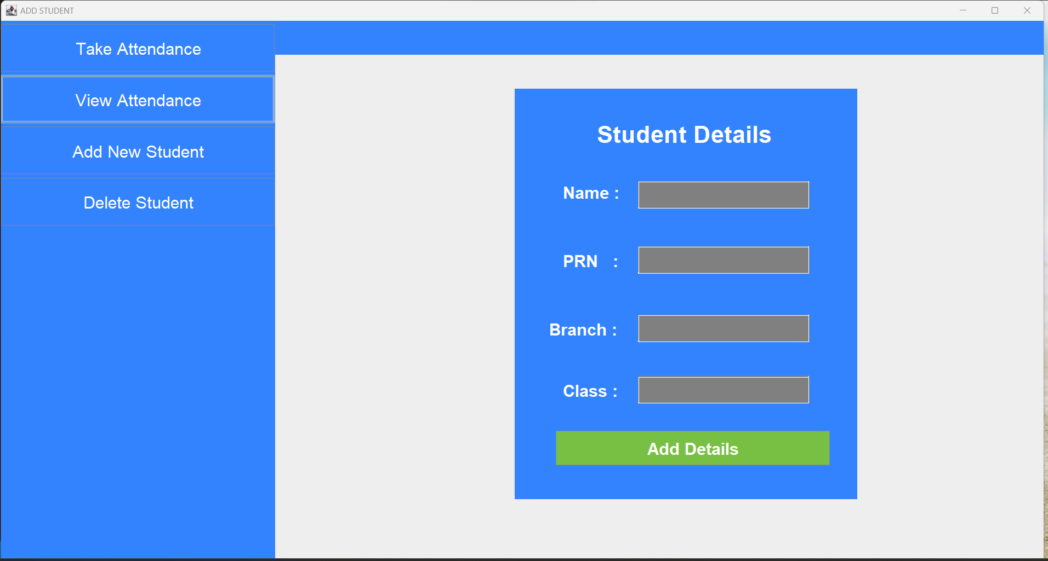

**6.Delete Page**

This function is used for deleting the data of the student which is unwanted or the student who are pass out from the institute or the schools. This feature is helpful while any student is no more a part of the institute whose information interrupt the teachers or users to mark attendance

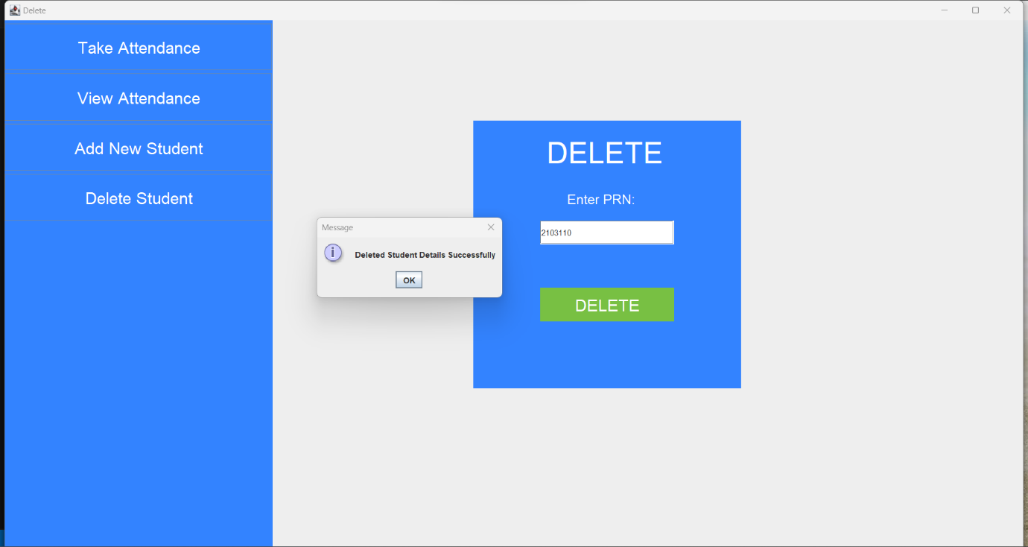

**7. Database**

Database Connectivity:-

●For database connectivity, required five steps are followed:

1.Register the Driver

2.Create a Connection

3.Create SQL Statement

4.Execute SQL Statement

5.Closing the connection.

●Package supporting the database is java.sql.*;

●Commands used for queries :

1.DDL

2.DML

A)**DDL** - alter, rename, create.

a)**alter** :- ALTER TABLE is used to add, delete/drop or modify columns in the existing table. It is also used to add and drop various constraints on the existing table. ADD is used to add columns into the existing table. Sometimes we may require to add additional information, in that case we do not require to create the whole database again, ADD comes to our rescue. DROP COLUMN is used to drop columns in a table. Deleting the unwanted columns from the table. MODIFY TABLE is used to modify the existing columns in a table. Multiple columns can also be modified at once. is used to modify the existing columns in a table. Multiple columns can also be modified at once.

b)**rename** :- The rename command is used to change the existing table name and give a new name to the table.

B)**DML** - select, insert, delete, update.

a)**select**: - SELECT is the most important data manipulation command in Structured Query Language. The SELECT command shows the records of the specified table. It also shows the record of a particular column by using the WHERE clause.

b)**insert**: - INSERT is another most important data manipulation command in Structured Query Language, which allows users to insert data in database tables.

c)**delete**: - DELETE is a DML command which allows SQL users to remove single or multiple existing records from the database tables. This command of Data Manipulation Language does not delete the stored data permanently from the database. We use the WHERE clause with the DELETE command to select specific rows from the table.

d)**update**: - UPDATE is another most important data manipulation command in Structured Query Language, which allows users to update or modify the existing data in database tables.

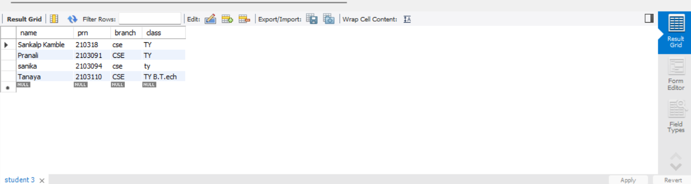

**Conclusion**

In conclusion, the Student Attendance System, crafted with Java, represents a significant leap forward in the realm of educational technology, addressing the crucial need for efficient attendance management. This comprehensive system is purpose-built to simplify the recording, monitoring, and accessibility of student attendance data, encompassing key information such as individual attendance records, class-wise statistics, and historical trends.

The project's core objectives were to provide an intuitive, user-friendly interface that streamlines attendance tracking for teachers, students, and administrators. Leveraging the power of Java, the system offers a robust and scalable solution, facilitating real-time updates and ensuring accurate and timely attendance information.

Emphasizing the importance of data security and privacy, the Student Attendance System employs rigorous authentication mechanisms to protect sensitive student information. The implementation adheres to industry standards, fostering a secure environment for attendance management within educational institutions.

The success of this project is not just a reflection of technical competence but also a demonstration of its potential impact on educational processes. By automating attendance tracking, the system contributes to operational efficiency, allowing educators to focus more on teaching and students on learning.

As the Student Attendance System progresses toward implementation, it holds the promise to revolutionize how educational institutions handle attendance records. The dedication and hard work invested in this project underscore its importance in enhancing the overall educational experience. With its emphasis on accuracy, accessibility, and security, the system is poised to make a positive contribution to the educational landscape, ensuring a more streamlined and effective attendance management process.

**References**

1.Java documentation for Swing components: https://docs.oracle.com/javase/tutorial/uiswing/components/index.html

2. MySQL documentation for database management:

https://dev.mysql.com/doc/

3.JDBC documentation for database connectivity: https://docs.oracle.com/javase/tutorial/jdbc/index.html

These resources provide detailed information on the components and technologies used in the development of the hospital patient database system, and can serve as valuable references for further learning and development.